Week-5
Employe database
1. creating tables (dept, employee, project, incentives, assigned_to)
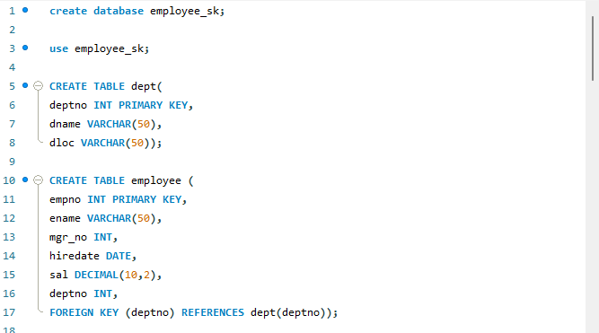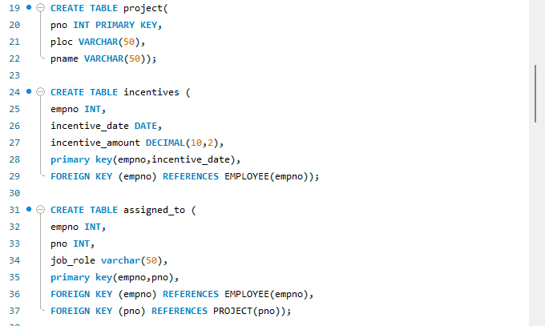

2. inserting tuples into the tables created.
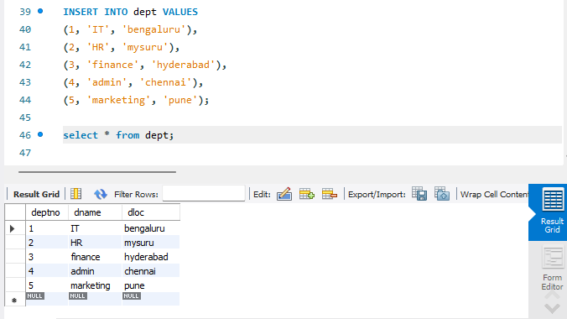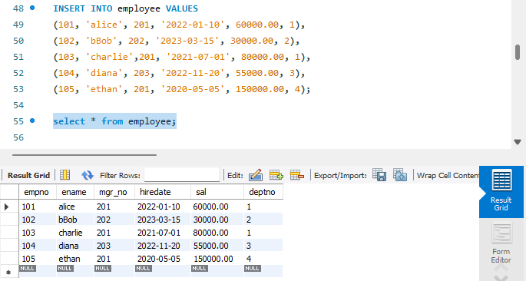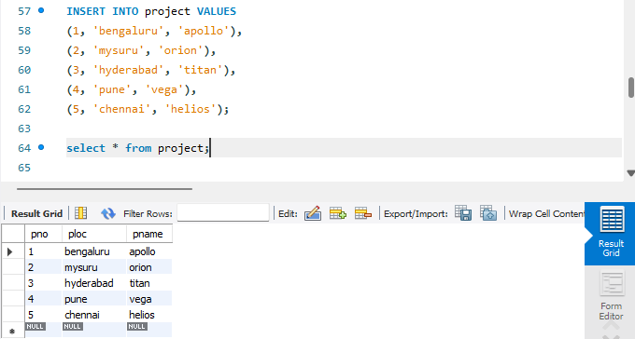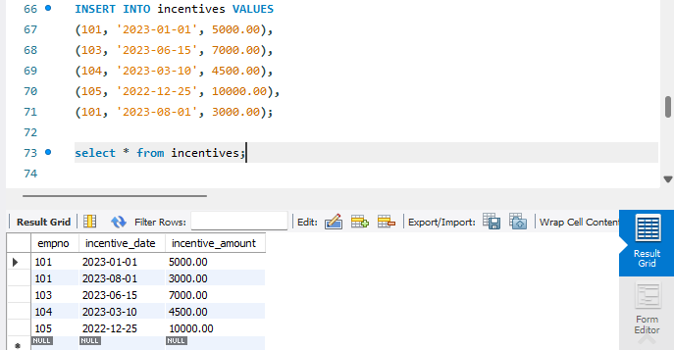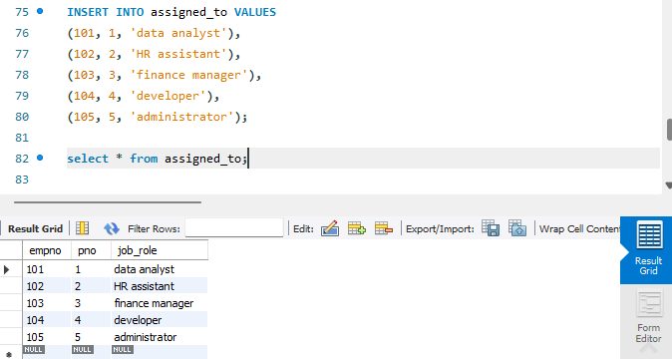

3. Retrieve the employee numbers of all employees who work on project located in
Bengaluru, Hyderabad, or Mysuru.
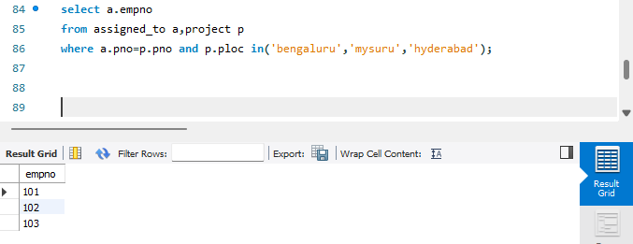
4. Get Employee ID’s of those employees who didn’t receive incentives
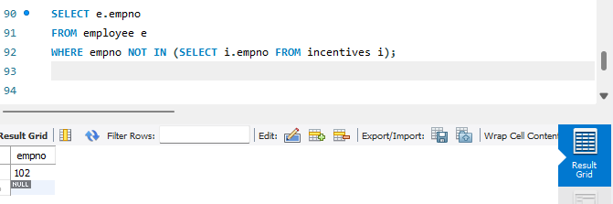

5. Write a SQL query to find the employees name, number, dept, job_role, department
location and project location who are working for a project location same as his/her
department location
